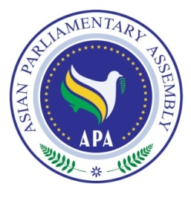
Asian Parliamentary Assembly
The 11th Plenary Session

“Promoting Economic Prosperity in Asia”

Draft Agenda of the
11th Plenary Session
28 November – 3 December 2018
İstanbul, TURKEY

- Adoption of the Agenda
- Election of the Bureau
- Report of the Chairperson of the 2nd Executive Council Meeting,
- General Debate: Statements and Presentations by Heads of Delegation on “Promoting Economic Prosperity in Asia”
5. Meeting of the Standing Committees
6. Meeting of Drafting Committee on Istanbul Declaration
7. Presentation of Reports of:
-Standing Committee on Social and Cultural Affairs
-Standing Committee on Political Affairs
-Standing Committee on Economic and Sustainable Development
-Standing Committee on Budget and Planning

8. Adoption of APA Resolutions
9. Adoption of the Report of 11th Plenary Session
10. Reconfirmation of the next APA President for 2020-2021
11. Any other matter
12. Closing

As of 27 November 2018
APA Secretariat

